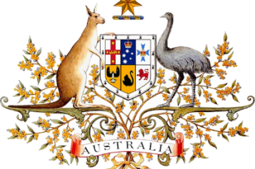
Federation

Beginnings
For at least 50 000 years, Indigenous people have lived on the Australian continent and practised traditional cultures and languages. From the late 1700s British colonies were founded in Australia. In 1901, these colonies (New South Wales, Victoria, Queensland, South Australia, Western Australia and Tasmania) came together and formed the nation of Australia through a process known as federation.
Before 1901 Australia did not exist as a nation. The six British colonies were like six separate countries. Each colony had a parliament that could make laws, but was still subject to the authority of the British Parliament. Each had its own defence force, issued its own stamps and collected tariffs (taxes) on goods that crossed its borders. The colonies even had different railway systems.

Federation fever
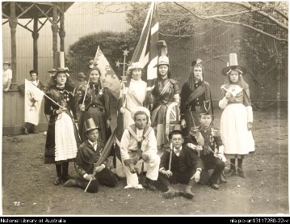
Popular support for federation grew in the 1880s and 1890s as people realised the colonies would be stronger and more efficient if they united. It was felt a national government was needed to deal with issues such as trade, foreign policy, immigration and defence. Although most colonists were of British descent and looked to Britain as the 'mother country', they had started to see themselves as belonging to one separate nation.

WHY FEDERATE

Path to federation
Before the colonies could unite, they had to agree how federation would work and make sure it was fair for everyone. Federation would require that each colony give some of their powers to a national parliament. The colonies decided they needed a set of rules, or constitution, for how Australia should be run.
The Constitution was then approved in referendums, a vote of the people, held in each colony between June 1899 and July 1900.
Before federation could proceed, the British Parliament had to agree to the Constitution. An official group of colonists, including Edmund Barton (Australia’s first Prime Minister), travelled to London to present the Constitution to the British Parliament.
The Commonwealth of Australia Constitution Act was passed by the British Parliament in July 1900. It allowed the six colonies to become Australian states and created the federal, or Commonwealth, Parliament.

One destiny for the nation
The nation of Australia came into being on 1 January 1901 at a ceremony held in Centennial Park in Sydney. During the ceremony, the Governor-General, Lord Hopetoun, was sworn in. Then Australia’s first Prime Minister, Sir Edmund Barton, and federal ministers took the oath of office.
FEDERATION CELEBRATIONS
Many Australians welcomed nationhood. Up to 500 000 people lined the route of the federation parade that travelled from the Domain to Centennial Park. About 100 000 spectators witnessed the ceremony that followed. Australians were ready to unite under the slogan 'one people, one flag, one destiny'.
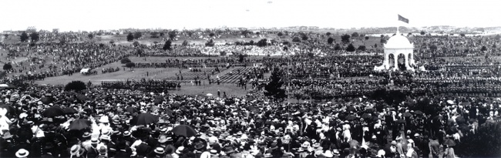+
Australians celebrate federation at Centennial Park, Sydney

Answer these questions in your notes:
- How many British colonies were there in Australia before 1901?
- Give one reason why the colonies decided to federate.
- On what date did Australia become a nation?
- At the time of federation which country did the colonies look to as the ‘mother country’?
- What is the Australian Constitution?
- What did the British Parliament do so Australia could federate?
- What was the name of Australia’s first Prime Minister?
- How many people watched the ceremony in Centennial Park when Australia was declared a nation?

